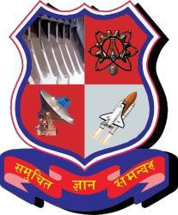 

**SARDAR VALLABHBHAI PATEL INSTITUTE OF TECHNOLOGY**

A REPORT ON

**HAND GESTURED ARDUINO ROBO**

Under the subject of

**DESIGN ENGINEERING-2B**

**B.E. III, Semester – VI**

**(COMPUTER ENGINEERING)**

Submitted by:

Group:

|  |  |  |
| --- | --- | --- |
| Sr. No. | Name of Student | Enrollment No. |
| 1 | Samruddhi Landge | 150410107037 |
| 2. | Krishna Mayavat | 150410107041 |
| 3. | Meet Soni | 150410107042 |
| 4. | Mitali Maniyar | 150410107048 |

Assistant Prof. Purvik Rana

(Faculty Guide)

Prof. Bijal Talati

(Head of the Department)

Academic year

(2017-2018)

**SARDAR VALLABHBHAI PATEL INSTITUTE OF TECHNOLOGY**

**VASAD–388306, GUJARAT–INDIA**

***Certificate***



Date:

This is to certify that students with En.no. 150410107037, 150410107041, 150410107042, 150410107048 Of program **Computer Engineering** [Third Year, 6th Semester] have satisfactorily completed their term work in course **Design Engineering-2B[2160001]** for the term ending in **April 2018.**

**Staff In-Charge Head of Department**

**Mr Purvik Rana Ms. B. J. Talati**

Assistant Professor Assistant Professor

C.E. Department C.E. Department

**TABLE OF CONTENTS**

1. **Introduction**
2. **Preparation of Canvases**
3. **Modelling and Analysis using Software**
4. **Engineering Economics Of Design**
5. **Design For Use, Reuse And Sustainability**
6. **Prototyping**
7. **Real Working Prototype**
8. **Test The Prototype**
9. **Measuring Instruments/ Techniques - Knowledge And Use, Manufacturing/Fabrication Process, Electronic Circuit/Boards, Open Source Tool**
10. **Comparison of existing materials, methods, tools and equipment for your project and justify your selection of materials, methods, tools and equipment etc..**
11. **Conclusion/Future scope**

**1. INTRODUCTION**

Our domain area is Internet of Things. We have specifically developed our device to search lost object to make people’s life easier. We have also considered many problems solving examples. In product development canvas we have given the description of our product, its specification, function, features, purpose, components.

In reverse engineering we have researched on our product and gained much knowledge about it. We have also discussed the technical aspects of our project, redesigned our idea and worked on the improved design.

We took the feedback analysis which helped us know the customer’s point of view and tried to solve their queries.

.

**2. PREPARATION OF CANVASES**

**1) AEIOU**

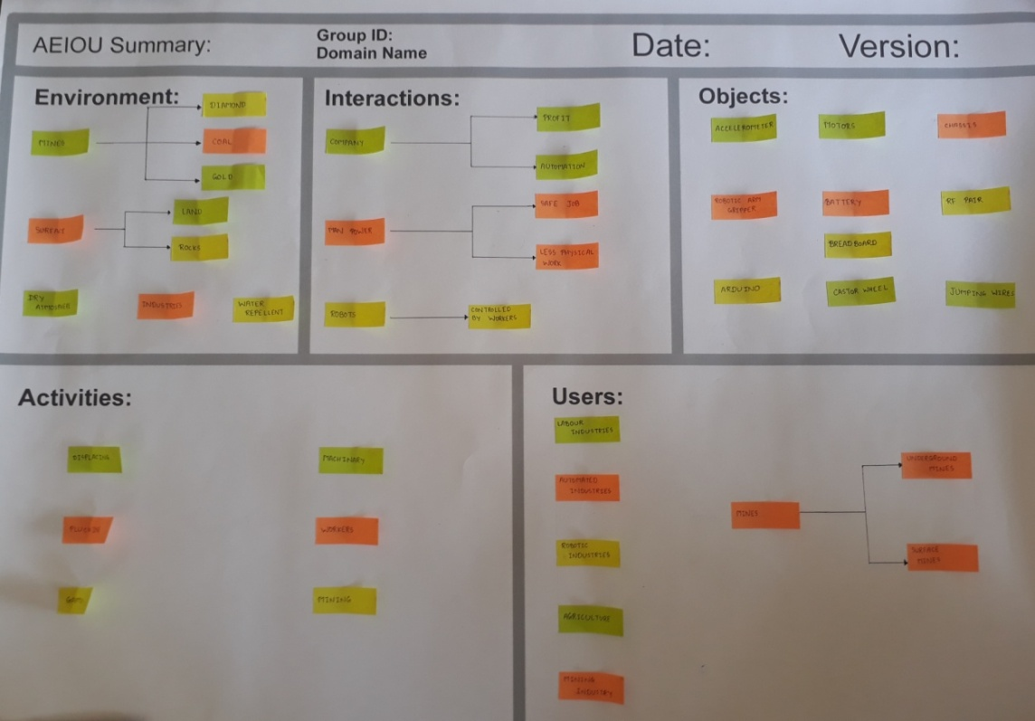

**2) EMPATHY MAPPING**

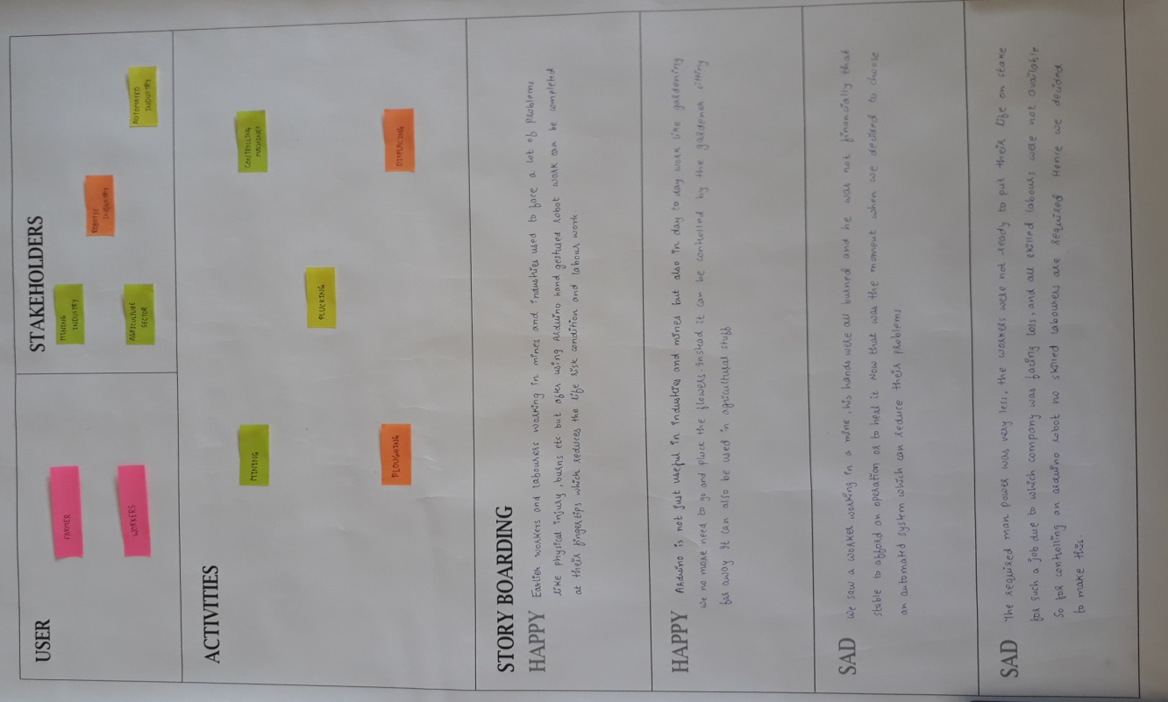

**3) MIND MAPPING**

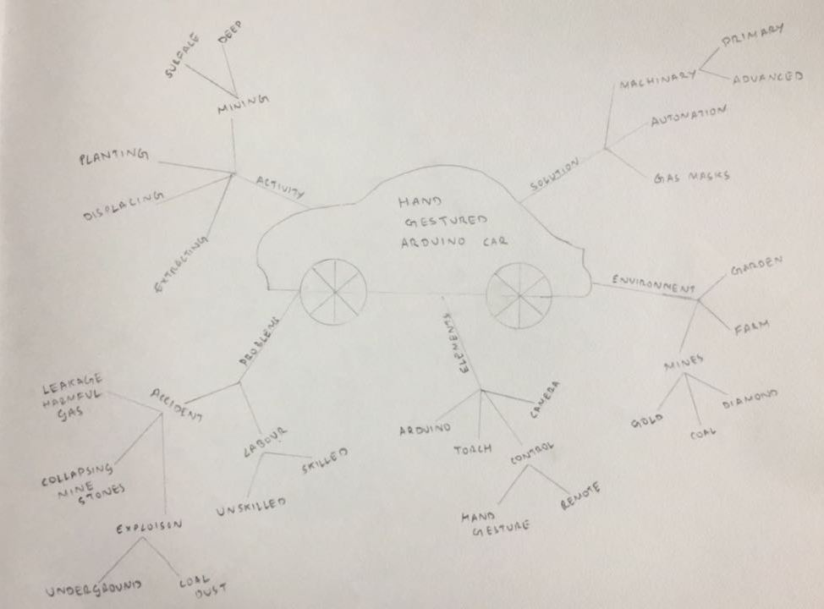

**4) IDEATION**

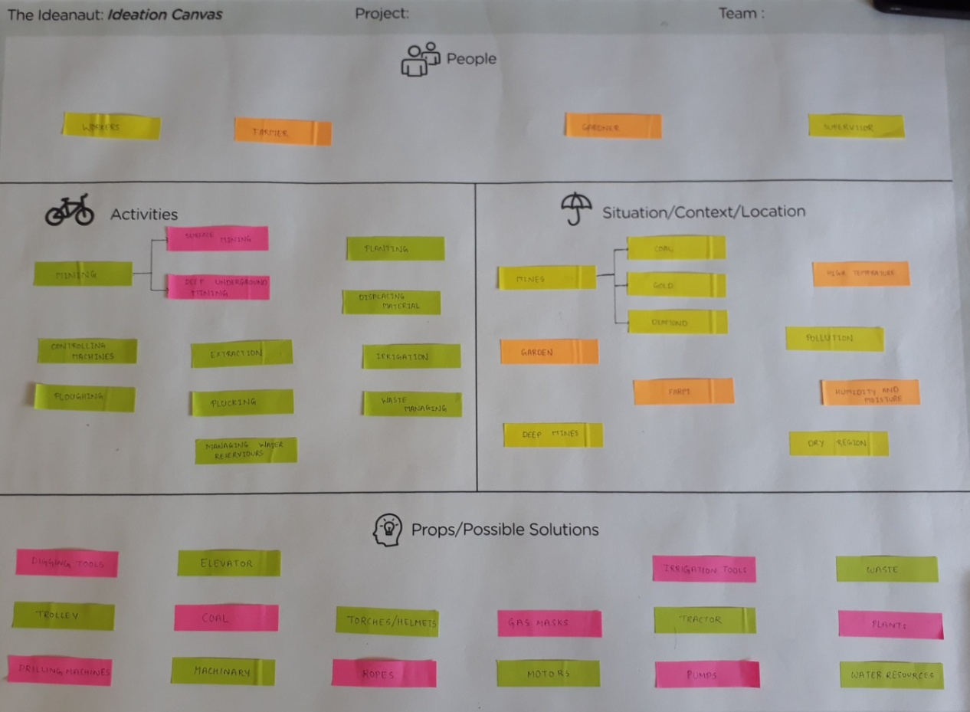

**5) PRODUCT DEVELOPMENT**

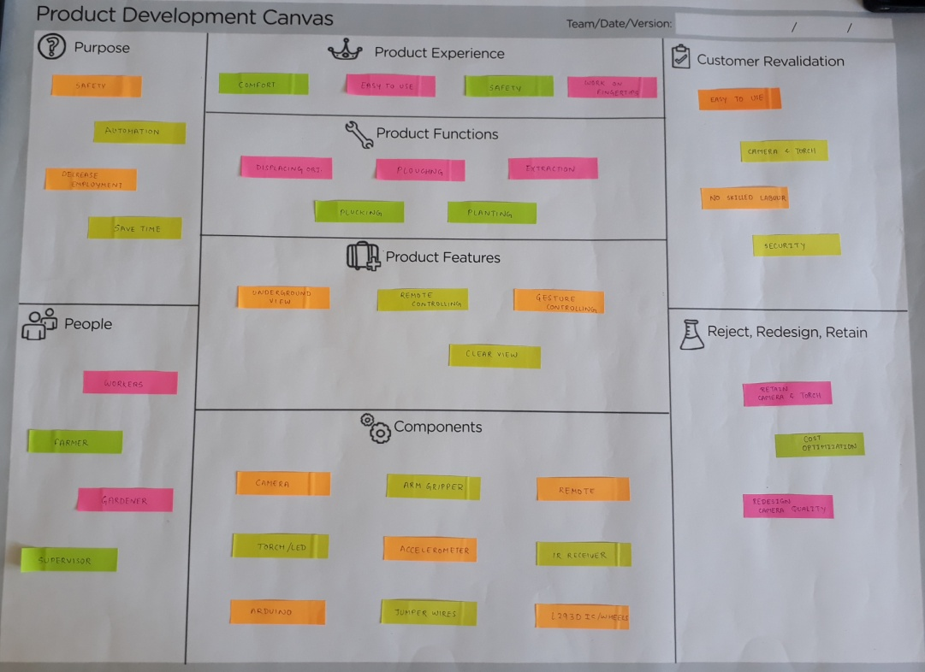

**6) LNM MATRIX**

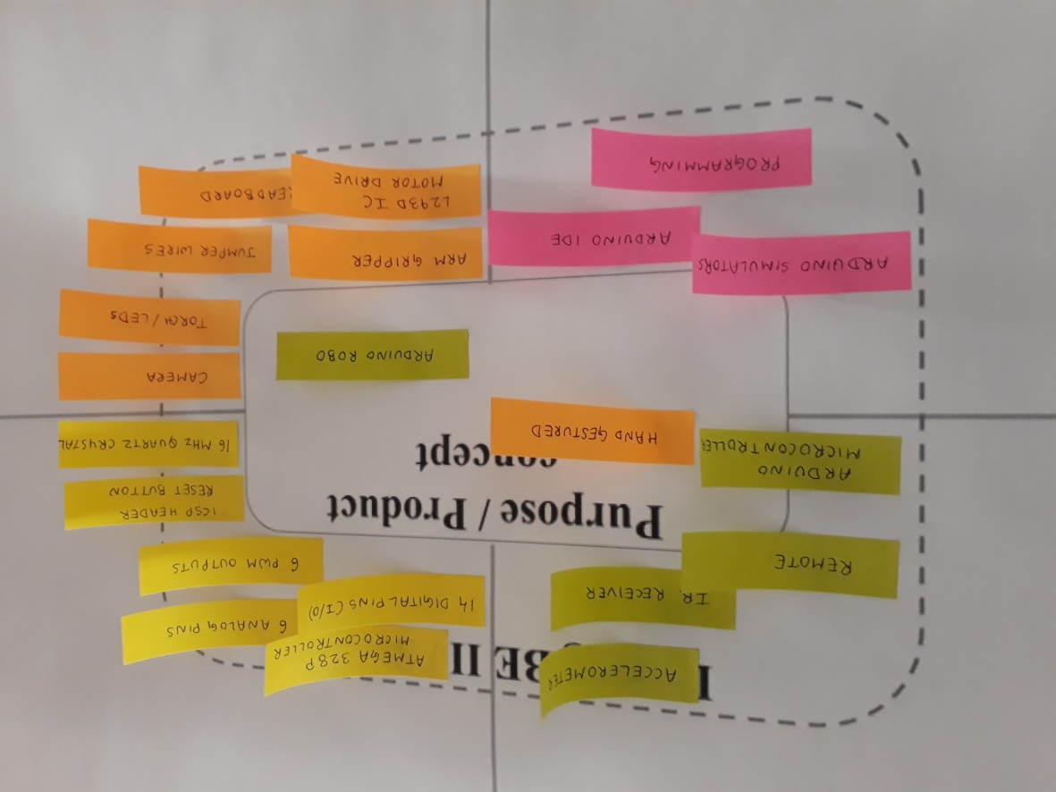

**3. MODELING AND ANALYSIS USING SOFTWARE**

**4. ENGINEERING ECONOMICS OF DESIGN**

**A) COST ESTIMATION**

* In our project we have made use of two Arduino UNO boards.

Instead of that we can replace one of the arduino board with only the microcontroller chip which reduces the cost.

* The hardware we will be using are Arduino boards, chassis, jumper wires, L293D motor, arm gripper, Accelerometer and FR receiver transmitter, camera etc..
* The estimated cost will be around INR 2000- INR 3000.

**B) LABOUR, MATERIAL AND OVERHEAD COSTS**

* Since our team members are all students so there is no direct labour cost.
* The system made by will require one person to control it so his wage can be added as indirect labour cost.
* The estimated cost above will be the material cost of our product.

**5. DESIGN FOR USE, REUSE AND SUSTAINABILITY**

**DESIGN FOR USE – HOW LONG THIS DESIGN WILL WORK?**

We have developed this product mainly because it is not applied in the real life scenarios. We think this product will be useful for sufficient amount of time so that it can make people’s life better.

And Artificial Intelligence can be applied to this system so that it will become more powerful and more efficient (removing the gestures).

* **Reliability:**

The system is reliable in a way that it will not harm the industry’s workforce thus by ensuring the safety of their employees or labourers.

Also we have just developed a prototype which is to be further developed in the large scale. On the large scale there will be more powerful and real time systems and more reliable. It won’t use Arduinos and other small components.

It will be able to withstand high temperature and high moisture levels or uneven surfaces, etc.

* **Maintainability:**

This system developed on the large scale will be more reliable and the maintenance will be also easier since it will be able to withstand unfavourable conditions far better. For example, the Arduino is not able to withstand high temperatures and is not water proof. But in that case it has to fulfil these holes in the current prototype.

**DESIGN FOR REUSE:**

The system can be reusable. Like for example one part of the machine is damaged or under-performing then we can use that component in some other low level area. And if it is damaged then it can be replaced by the new component and thus the whole system won’t be useless by damage of some of its part.

**DESIGN FOR SUSTAINABILITY:**

The robot ensures sustainability by making sure the human lives are saved and if it is used in gardening and farming it helps nature in a certain way.

It also does not pollute the environment thus there is no pollution caused by the bot.

**6. PROTOTYPING**

1. **INVENTORY**

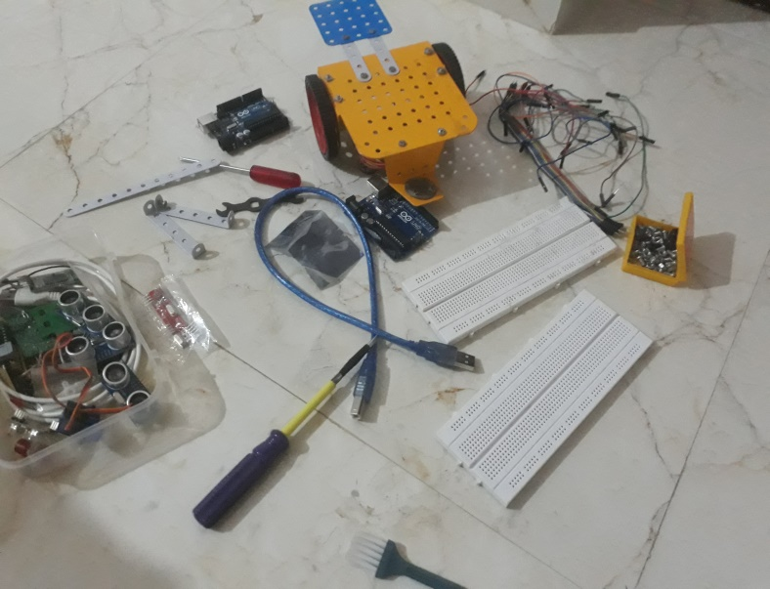

1. **CHASSIS(BODY)**

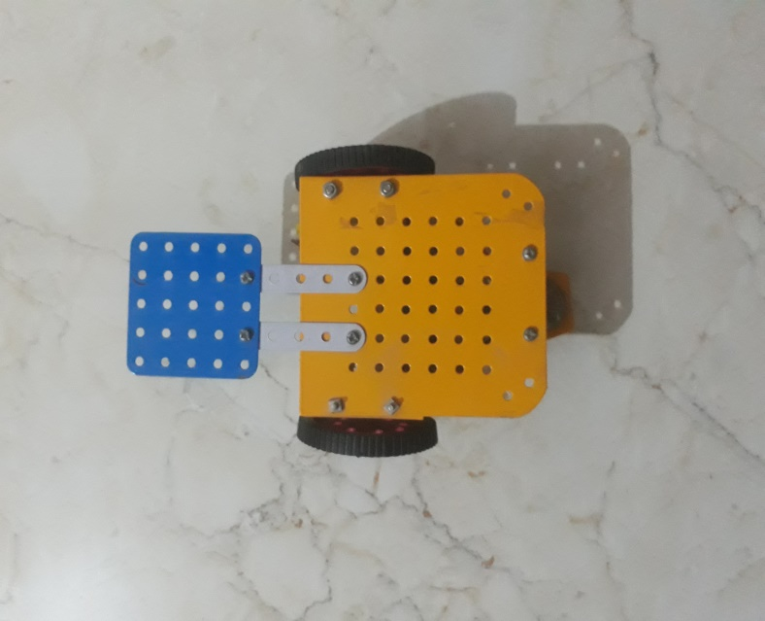

1. **ATTACHING BO MOTORS WITH THE L293D MOTOR DRIVER**

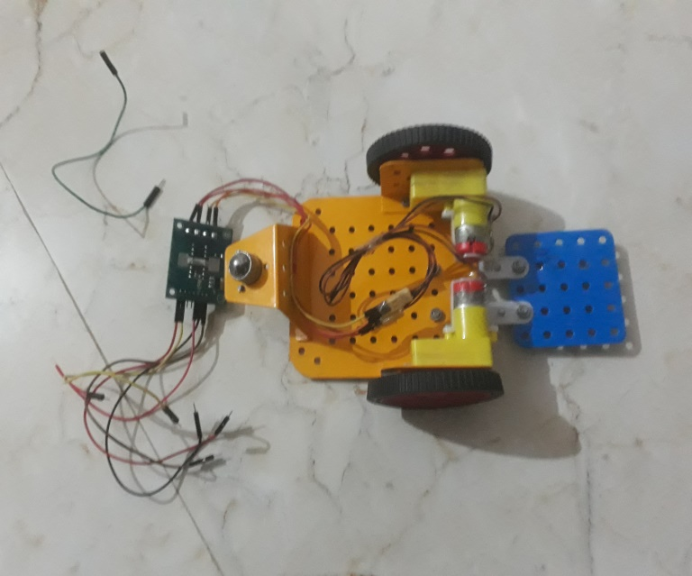

1. **CONNECTING RF RECEIVER**

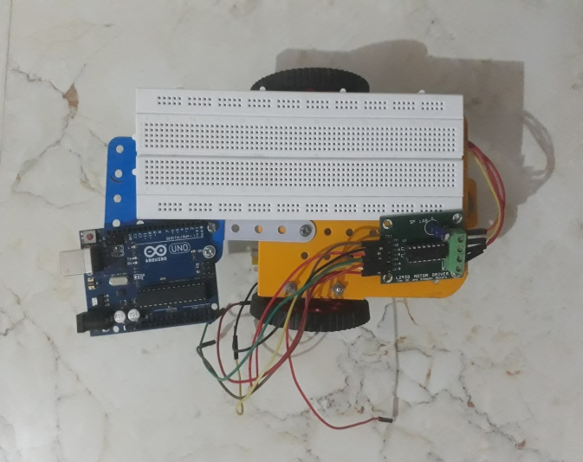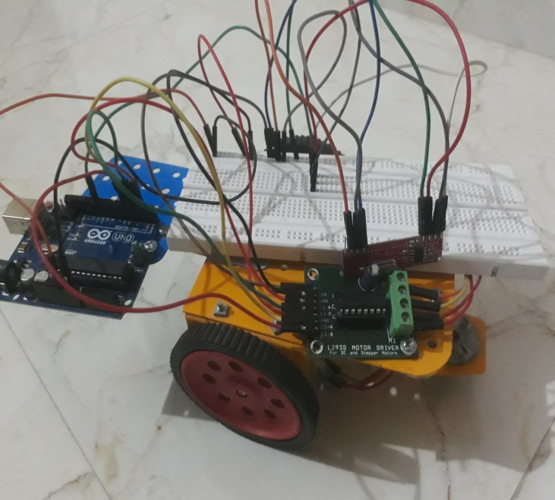

1. **MAKING THE REMOTE(SECOND PART)**

**Here we are connecting the ADXL335 Accelerometer with the arduino via breadboard.**

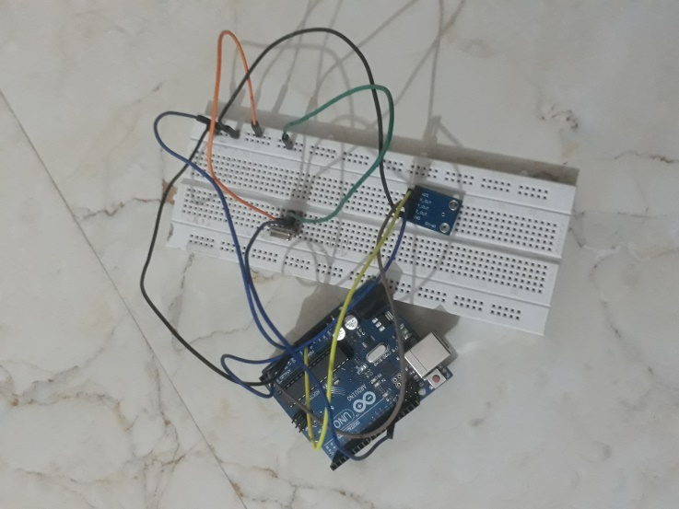

1. **Final both the modules**

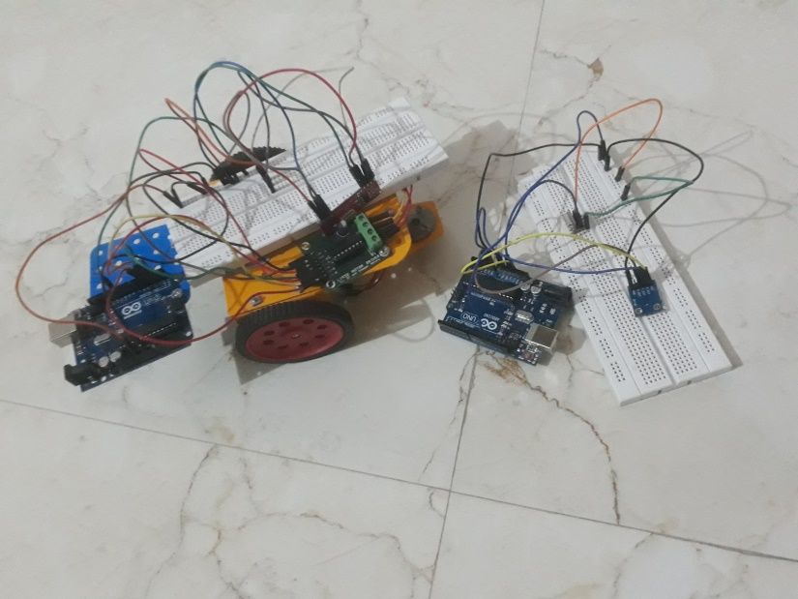

**7. TEST THE PROTOTYPE**

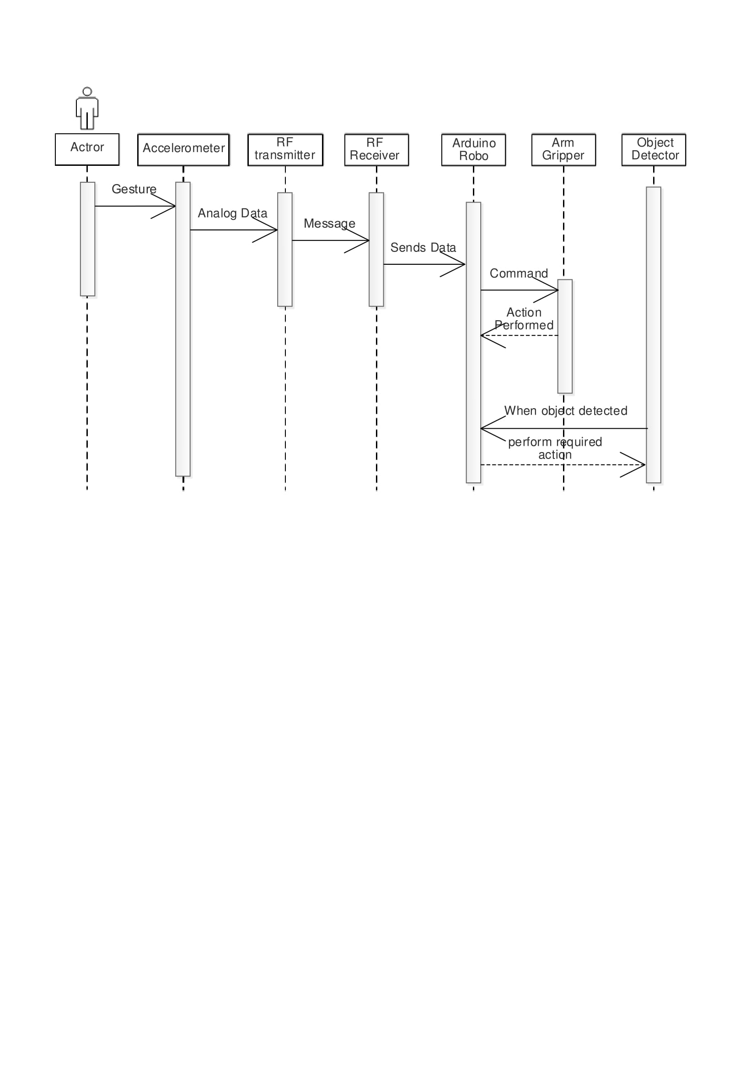

**8. MEASURING INSTRUMENTS/ TECHNIQUES - KNOWLEDGE AND USE, MANUFACTURING/FABRICATION PROCESS, ELECTRONIC CIRCUIT/BOARDS, OPEN SOURCE TOOL**

**Electronic Board:** ARDUINO UNO

**Open Source Tool:** ARDUINO IDE 1.6.3

**Comparison with present Technology:**

Currently in the market only the machines for displacing objects are available. Our product also gives much more features than just displacing the objects.

Also the technology that we are using is the ***INTERNET OF THINGS*** ***(IOT)*** which is one of the trending technologies.

**9. CONCLUSION/ FUTURE SCOPE**

In this semester, we have finished the prototype development of our product. We hope that the implementation of our prototype on large scale will make the lives of the targeted customers.

And if we can use Artificial Intelligence the scope of this project may increase unpredictably.